**Bash scripting task – 03**

**1) Bash script to print odd numbers from the list. (12,5,7,10,8,19,20,23,25)**

**Commands used:**

**vi <file_name.bash>** - To create and edit bash script.

**chmod 755 <file_name.bash>** – To change permissions.

**Cat <file_name.bash>** - To check content once again before execute.

**./ <file_name.bash>** - To run the script.

**numbers=(...)** : Defines an array of numbers.

**for num in "${numbers[@]}"** : For Loop, loops through each number.

**if [ $((num % 2)) -ne 0 ]** : Checks if number is Odd, -ne(not equal to)

**echo $num** : Prints the Odd number.

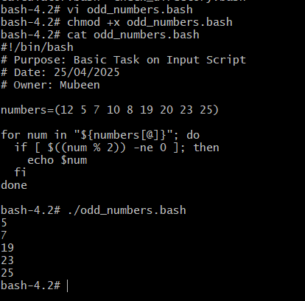

**2) Bash script to take a input from user and check if it is greater than or less than 10**

**Commands used:**

**vi <file_name.bash>** - To create and edit bash script.

**chmod 755 <file_name.bash>** – To change permissions.

**Cat <file_name.bash>** - To check content once again before execute.

**./ <file_name.bash>** - To run the script.

**read -p "Enter a number: " num** : Gets input from user.

**if [ $num -gt 10 ]** : Checks if number is Greater Than 10.

**elif [ $num -lt 10 ]** : Checks if number is Less Than 10.

**else** : If number is neither greater nor less than 10, it must be Equal To 10.

**If-Elif-Else Statement**: to check number conditions.

Comparison Operators:

**-gt** : Greater Than

**-lt** : Less Than

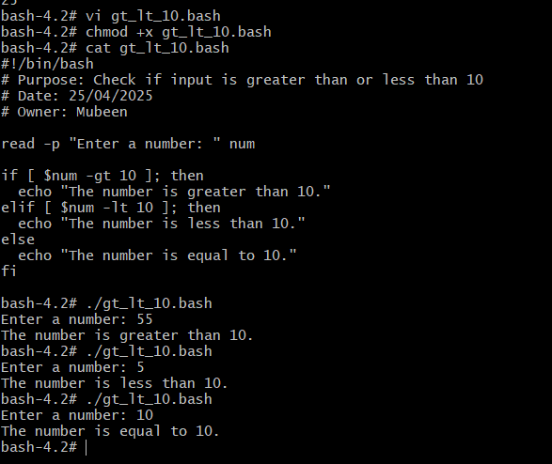

**3) Bash script to login to multiple servers and check if httpd service is running or not.**

**Commands used:**

**vi <file_name.bash>** - To create and edit bash script.

**chmod 755 <file_name.bash>** – To change permissions.

**Cat <file_name.bash>** - To check content once again before execute.

**./ <file_name.bash>** - To run the script.

**For loop** condition.

SERVERS**=("..." "..." "...")** : Defines an array of server IP addresses.

for SERVER in **"${SERVERS[@]}";** do : Loops through each server IP address.

**ssh** : Connects to the server using SSH.

**-o "StrictHostKeyChecking=accept-new"** : Automatically accepts new host keys.

**-i "$KEY_FILE"** : Specifies the private key file.

**"$USERNAME@$SERVER"** : Specifies the username and server IP address.

**"systemctl status httpd"** : Checks the status of the httpd service.

**| grep "Active:"** : Searches for the string "Active:" in the output.

**done** : Ends the loop.

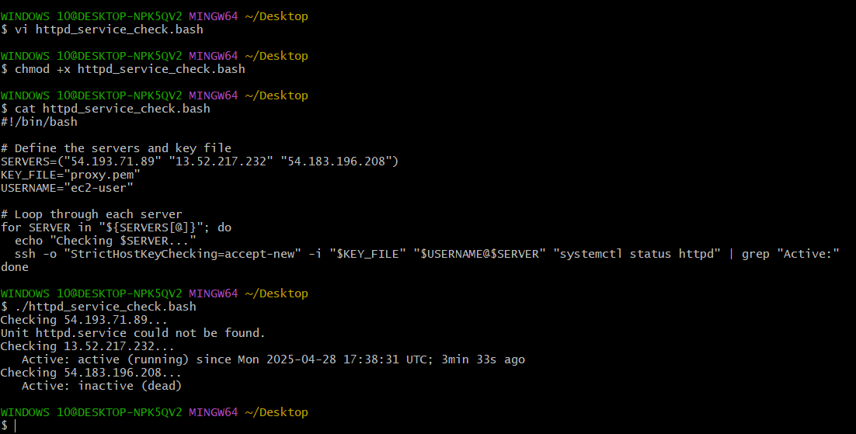

**4) Bash script to check the log files from a path and delete files older than 20 days.**

**Commands used:**

**vi <file_name.bash>** - To create and edit bash script.

**chmod 755 <file_name.bash>** – To change permissions.

**Cat <file_name.bash>** - To check content once again before execute.

**./ <file_name.bash>** - To run the script.

**If else** statement.

**find**: Searches for files based on various conditions.

**-type f:** Specifies file type.

**-name "*.log"**: Specifies file name pattern.

**-mtime +20**: Specifies file modification time.

**-delete**: Deletes files.

**-print**: Prints deleted file names.

**if [ -n "$deleted" ]:** If Statement, checks if deleted variable is not empty.

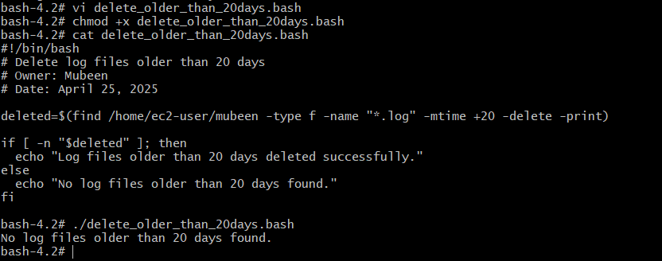

**5) Bash script to print 3rd word and 5th word from the given input of user**

**Commands used:**

**vi <file_name.bash>** - To create and edit bash script.

**chmod 755 <file_name.bash>** – To change permissions.

**Cat <file_name.bash>** - To check content once again before execute.

**./ <file_name.bash>** - To run the script.

**read -p**: Gets input from the user.

**set --**: Sets positional parameters 1-2-3-4-5.

**$3 and $5**: Reference for the 3rd and 5th words.

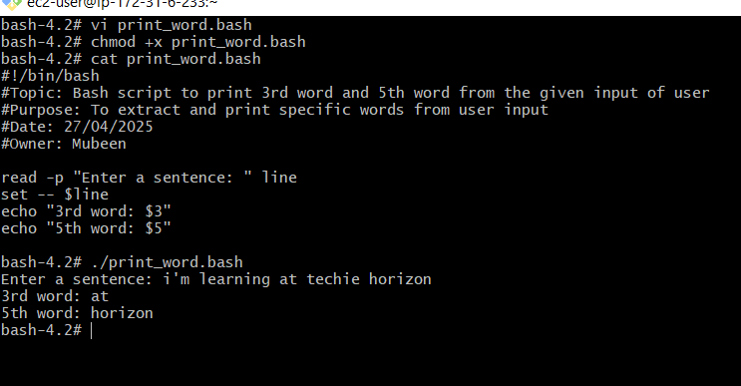

**6) Bash script to print numbers between 1 to 100 and then seperate the odd numbers and even numbers**

**Commands used:**

**vi <file_name.bash>** - To create and edit bash script.

**chmod 755 <file_name.bash>** – To change permissions.

**Cat <file_name.bash>** - To check content once again before execute.

**./ <file_name.bash>** - To run the script.

**for num in {1..100}**: For Loop, to print 1 to 100.

**$((num % 2))**: Arithmetic Expansion, calculates remainder.

**if [ ... -eq 0 ]:** If Statement, if it is equal to 0 then even or else odd.

